



| Plantillas de programación en HTML, CSS y JavaScript |
| --- |

Si quieres editar una versión de este documento, tienes dos formas de hacerlo:

1. Modificar esta versión directamente
2. Ir a Archivo > Descargar > Microsoft Word

Cómo usar estas plantillas

Copia y pega estas plantillas de código en tu CMS para incluir el elemento que necesites en tu sitio web.

Las plantillas son completamente personalizables, por lo que puedes cambiar lo que necesites para adaptarlas a tus necesidades, y también puedes editar los fragmentos de código.

Índice de plantillas

| Menús y rutas de navegación | Botones de transición |
| --- | --- |
| Formularios web y barras de búsqueda | Elementos modales lightbox |
| Textos emergentes | Barras de progreso |
| Acordeones CSS | Efectos CSS |
| Pestañas de navegación CSS | Presentaciones de CSS y JavaScript |
| JavaScript onClick con CSS | Video y audio HTML |
| Fondos CSS | Degradados CSS |
| Desplegables CSS | Animaciones CSS |

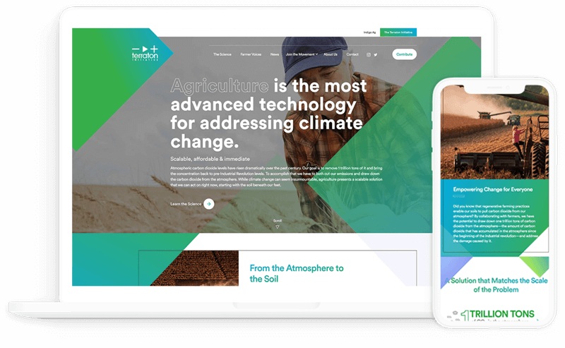

| Software de CMS de HubSpot  Software de gestión de contenido que ofrece al equipo de marketing la flexibilidad que necesita, tiene la potencia que el equipo de programación se merece y brinda a los clientes una experiencia segura y personalizada. | |  | |
| --- | --- | --- | --- |
|  | [Comenzar gratis](https://www.hubspot.es/products/cms?utm_source=offers&utm_campaign=ql-update_coding-templates) | |  |
|  | | | |

*Sigue bajando para ver las plantillas*

↓↓↓



|  |
| --- |
| Cuatro plantillas para menús y rutas de navegación |
|  |

# Plantilla n.° 1



## El HTML

<div class="container">

<nav>

<ul class="bar">

<li><a href="#">Inicio</a></li>

<li><a href="#">Información</a></li>

<li><a href="#" class="active">Contacto</a></li>

<li><a href="#">Empleo</a></li>

</ul>

</nav>

</div>

## El CSS

.bar {

background-color: rgb(245, 193, 97);

width: 100%;

height: 40px;

display: flex;

list-style: none;

padding: 0;

}

.bar li {

height: 100%;

width: 100px;

border-right: 1px solid rgb(235, 177, 69);

}

.bar li a {

color: black;

width: 100%;

height: 100%;

display: flex;

align-items: center;

justify-content: center;

text-decoration: none;

}

.bar li a:hover {

background-color: rgb(235, 177, 69);

}

.bar li a.active {

background-color: rgb(165, 113, 16);

color: white;

}

# 

# Plantilla n.° 2

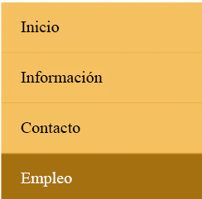

## El HTML

<div class="container">

<nav>

<ul class="bar">

<li><a href="#">Inicio</a></li>

<li><a href="#">Información</a></li>

<li><a href="#">Contacto</a></li>

<li><a href="#" class="active">Empleo</a></li>

</ul>

</nav>

</div>

## El CSS

.bar {

background-color: rgb(245, 193, 97);

max-width: 200px;

width: 100%;

list-style: none;

padding: 0;

}

.bar li {

height: 100%;

width: 100%;

height: 50px;

border-bottom: 1px solid rgb(235, 177, 69);

}

.bar li a {

padding-left: 20px;

text-align: left;

color: black;

max-width: 100%;

height: 100%;

display: flex;

align-items: center;

text-decoration: none;

}

.bar li a:hover {

background-color: rgb(235, 177, 69);

}

.bar li a.active {

background-color: rgb(165, 113, 16);

color: white;

}

# 

# Plantilla n.° 3



## El HTML

<div class="container">

<nav>

<ul class="bar">

<li><a href="#" class="active">Inicio</a></li>

<li class="has-dropdown">

<a href="#">Información</a>

<ul class="dropdown">

<li><a href="#">La empresa</a></li>

<li><a href="#">El equipo</a></li>

</ul>

</li>

<li class="has-dropdown">

<a href="#">Contacto</a>

<ul class="dropdown">

<li><a href="#">Email</a></li>

<li><a href="#">Teléfono</a></li>

</ul>

</li>

<li><a href="#">Empleo</a></li>

</ul>

</nav>

</div>

## El CSS

* {

box-sizing: border-box;

}

.bar {

background-color: rgb(245, 193, 97);

width: 100%;

height: 40px;

display: flex;

list-style: none;

padding: 0;

}

.bar li {

height: 100%;

width: 120px;

border-right: 1px solid rgb(235, 177, 69);

}

.bar li a {

color: black;

width: 100%;

height: 100%;

display: flex;

align-items: center;

justify-content: center;

text-decoration: none;

}

.bar .has-dropdown ul li a{

padding: 12px 0;

}

.bar li a:hover {

background-color: rgb(235, 177, 69);

}

.bar li a.active {

background-color: rgb(165, 113, 16);

color: white;

}

.dropdown {

background-color: rgb(245, 193, 97);

padding: 0;

list-style: none;

display: none;

}

.bar li.has-dropdown:hover .dropdown {

display: block;

}

# 

# Plantilla n.° 4



## El HTML

<div class="container">

<ul class="breadcrumb">

<li><a href="#" class="active">Inicio</a></li>

<li><span>></span></li>

<li><a href="#">Productos</a></li>

<li><span>></span></li>

<li><a href="#">Dispositivos</a></li>

<li><span>></span></li>

<li><a href="#" class="unique">Móviles</a></li>

</ul>

</div>

## El CSS

.breadcrumb {

list-style: none;

padding: 0;

display: flex;

font-size: 20px;

justify-content: space-around;

max-width: 450px;

}

.breadcrumb a {

text-decoration: none;

color: rgb(110, 110, 110);

font-weight: bold;

}

.breadcrumb li span{

color: gray;

}

.breadcrumb li a {

color: orange;

transition: color 300ms;

}

.breadcrumb li .unique {

color: #000;

}

.breadcrumb li a:hover {

color: rgb(176, 115, 0);

}



|  |
| --- |
| Tres plantillas para botones de transición    \\\ |
|  |

# Plantilla n.° 1



## El HTML

<button class="first">Pasar el cursor</button>

## El CSS

.first {

padding: 10px;

font-size: 20px;

background-color: black;

color: white;

border: none;

cursor: pointer;

box-shadow: 0 0 0 #ccc;

transition: box-shadow 300ms, color 300ms;

}

.first:hover {

color: yellow;

box-shadow: 10px 10px 0 rgb(219, 219, 219);

}

# Plantilla n.° 2

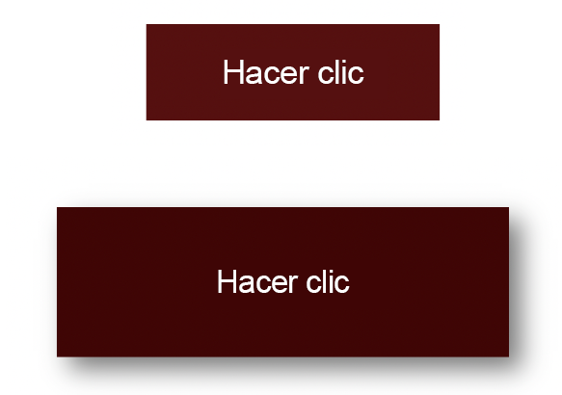

## El HTML

<button class="second">Hacer clic</button>

## El CSS

.second {

width: 180px;

height: 60px;

display: flex;

align-items: center;

justify-content: center;

font-size: 20px;

background-color: rgb(85, 16, 16);

color: white;

border: none;

cursor: pointer;

transition: transform 150ms,

font-size 150ms, color 150ms;

}

.second:active {

background-color: rgb(63, 5, 5);

font-size: 12px;

transform: scale(1.3);

box-shadow: 5px 5px 10px rgb(119, 119, 119);

}

# Plantilla n.° 3



## El HTML

<button class="third">Pasar el cursor</button>

## El CSS

.third {

border: none;

background: none;

width: 120px;

height: 40px;

cursor: pointer;

position: relative;

color: black;

transition: color 500ms;

overflow: hidden;

}

.third::after {

content: "";

background-color: #333;

color: white;

position: absolute;

left: 0;

bottom: -40px;

width: 100%;

height: 100%;

transition: bottom 500ms;

z-index: -1;

}

.third:hover {

color: white;

}

.third:hover::after {

bottom: 0;

}



|  |
| --- |
| Tres plantillas para formularios web y barras de búsqueda  \\\ |
|  |

# Plantilla n.° 1

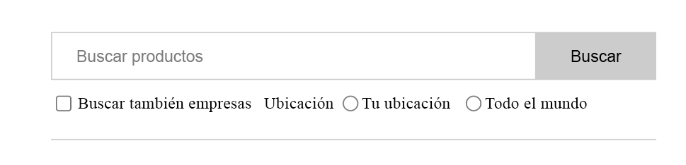

## El HTML

<form>

<div class="search">

<input type="text" placeholder="Search products" />

<button type="submit">Buscar</button>

</div>

<div class="align-center bottom">

<div class="checkbox-block">

<input

type="checkbox"

name="companies_included"

id="companies_included"

/>

<label for="companies_included"

>Buscar también empresas

</label>

</div>

<div class="inline-flex radio-block">

<span>Ubicación</span>

<div class="inline-flex align-center">

<input

type="radio"

name="location"

value="Tu ubicación"

id="your_location"

/>

<label for="your_location"> Tu ubicación </label>

</div>

<div class="inline-flex align-center">

<input

type="radio"

name="location"

value="Todo el mundo"

id="worldwide"

/>

<label for="worldwide"> Todo el mundo </label>

</div>

</div>

</div>

</form>

## El CSS

.align-center {

display: flex;

align-items: center;

}

.inline-flex {

display: inline-flex;

}

form {

padding: 20px 0;

max-width: 500px;

border-bottom: 1px solid #ccc;

}

.search {

display: flex;

outline: 1px solid #cccccc;

}

.search > input {

flex-grow: 1;

border: 0;

padding: 0.5rem 1rem;

font-size: 1rem;

}

.search > input:focus {

outline: none;

}

.search > button {

padding: 0.8rem 2rem;

border: 0;

cursor: pointer;

font-size: 1rem;

background: #cccccc;

}

.bottom {

margin-top: 10px;

font-size: 14px;

}

.checkbox-block {

display: flex;

align-items: center;

margin-right: 30px;

}

.checkbox-block input {

margin-right: 5px;

cursor: pointer;

}

.radio-block input {

margin: 0 3px 0 10px;

}

# Plantilla n.° 2

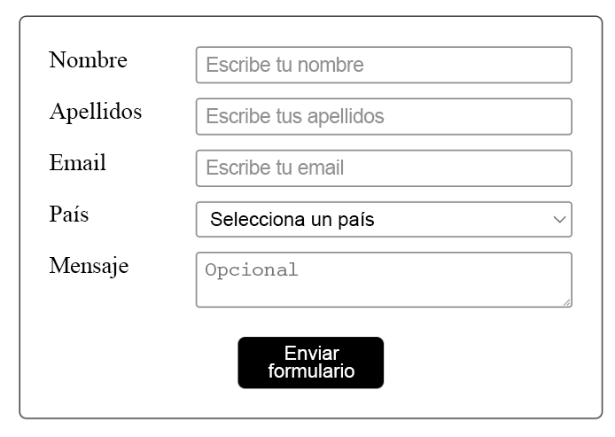

## El HTML

<form>

<div class="input-group">

<label for="fname">Nombre</label>

<input

id="fname"

name="fname"

placeholder="Escribe tu nombre"

required="required"

/>

</div>

<div class="input-group">

<label for="lname">Apellidos</label>

<input

id="lname"

name="lname"

placeholder="Escribe tus apellidos"

required="required"

/>

</div>

<div class="input-group">

<label for="email">Email</label>

<input

id="email"

type="email"

name="email"

placeholder="Escribe tu email"

/>

</div>

<div class="input-group">

<label>País</label>

<select name="country" id="country" required="required">

<option value="" selected="selected">Selecciona un país</option>

<option value="Afghanistan">Afganistán</option>

<option value="Albania">Albania</option>

<option value="Algeria">Argelia</option>

<option value="American Samoa">Samoa Americana</option>

<option value="Andorra">Andorra</option>

<option value="Angola">Angola</option>

<option value="Anguilla">Anguilla</option>

<option value="Antarctica">Antártida</option>

</select>

</div>

<div class="input-group">

<label for="message">Mensaje</label>

<textarea

id="message"

name="message"

placeholder="Opcional"

></textarea>

</div>

<div class="submit-group">

<button type="submit">Enviar formulario</button>

</div>

</form>

## El CSS

* {

box-sizing: border-box;

}

body {

margin: 30px;

}

form {

border: 1px solid #333;

padding: 20px;

max-width: 400px;

margin: 0 auto;

border-radius: 5px;

}

.input-group {

display: flex;

margin-bottom: 10px;

}

label {

width: 100px;

}

input,

select,

textarea {

flex: 1;

padding: 3px 5px;

}

.submit-group {

display: flex;

align-items: center;

justify-content: center;

margin-top: 20px;

}

button {

width: 100px;

margin: 0 auto;

background-color: black;

color: white;

border: none;

padding: 10px;

cursor: pointer;

border-radius: 5px;

}

# Plantilla n.° 2

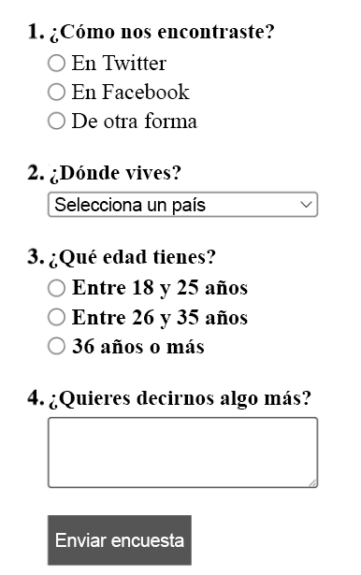

## El HTML

<form>

<div>

<span class="question">1. ¿Cómo nos encontraste?</span>

<div class="radio-group">

<div class="radio-item">

<input type="radio" name="hear_about_us" id="twitter" />

<label for="twitter">En Twitter</label>

</div>

<div class="radio-item">

<input type="radio" name="hear_about_us" id="facebook" />

<label for="facebook">En Facebook</label>

</div>

<div class="radio-item">

<input type="radio" name="hear_about_us" id="other" />

<label for="other">De otra forma</label>

</div>

</div>

</div>

<div>

<span class="question">2. ¿Dónde vives?</span>

<select name="country" id="country" required="required">

<option value="" selected="selected">Selecciona un país</option>

<option value="Afghanistan">Afganistán</option>

<option value="Albania">Albania</option>

<option value="Algeria">Argelia</option>

<option value="American Samoa">Samoa Americana</option>

<option value="Andorra">Andorra</option>

<option value="Angola">Angola</option>

<option value="Anguilla">Anguilla</option>

<option value="Antarctica">Antártida</option>

</select>

</div>

<div>

<span class="question">3. ¿Qué edad tienes?</span>

<div class="radio-group">

<div class="radio-item">

<input type="radio" name="age_range" id="lower" />

<label for="lower">Entre 18 y 15 años</label>

</div>

<div class="radio-item">

<input type="radio" name="age_range" id="middle" />

<label for="middle">Entre 26 y 35 años</label>

</div>

<div class="radio-item">

<input type="radio" name="age_range" id="higher" />

<label for="higher">36 años o más</label>

</div>

</div>

</div>

<div>

<span class="question">4. ¿Quieres decirnos algo más? </span>

<textarea name="message"></textarea>

</div>

<div>

<button class="submit-btn">Enviar encuesta</button>

</div>

</form>

## El CSS

* {

box-sizing: border-box;

}

body {

margin: 30px;

}

form {

max-width: 400px;

}

form > div {

margin-bottom: 20px;

}

.question {

font-weight: bold;

display: block;

margin-bottom: 5px;

}

.radio-group,

select,

textarea {

margin-left: 15px;

width: 200px;

}

textarea {

padding: 10px;

}

.radio-item {

display: flex;

align-items: center;

margin-bottom: 3px;

}

.radio-item label {

margin-left: 5px;

}

.radio-item input {

margin: 0;

}

.submit-btn {

margin-left: 15px;

background-color: #555;

border: 1px solid #555;

color: white;

padding: 10px;

cursor: pointer;

}



|  |
| --- |
| Cuatro plantillas para elementos modales lightbox  \\\ |
|  |

# Plantilla

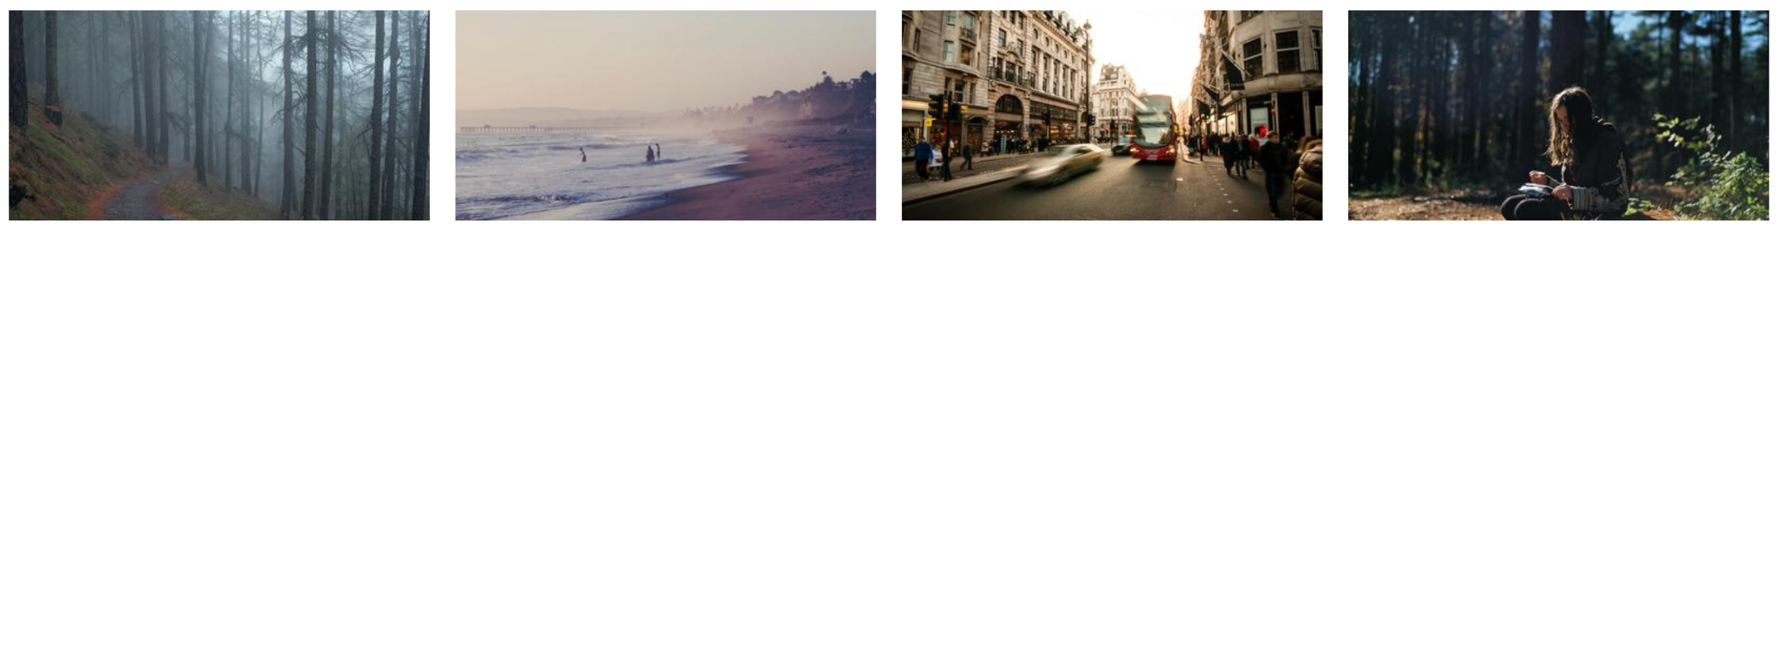

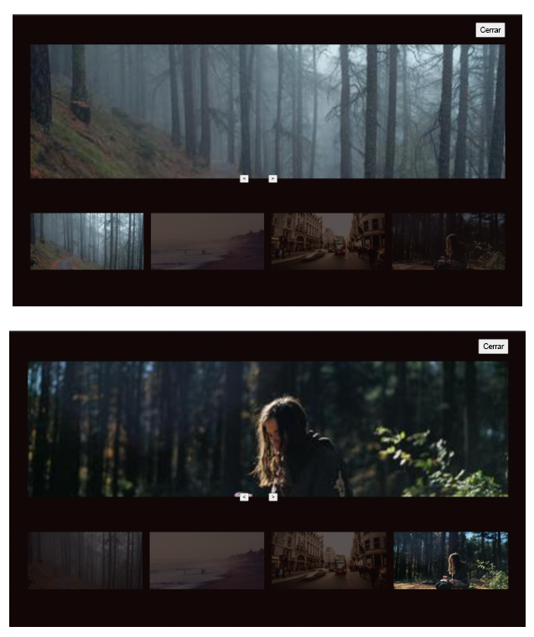

## El HTML

<div class="images">

<img onclick="openModal(0)" id="image0" />

<img onclick="openModal(1)" id="image1" />

<img onclick="openModal(2)" id="image2" />

<img onclick="openModal(3)" id="image3" />

</div>

<div id="lightbox" class="lightbox">

<button onclick="closeModal()" class="close-btn">

Cerrar

</button>

<div class="image-preview">

<img id="preview-image" />

</div>

<div class="control-btns">

<button onclick="control(-1)" class="control-left">

&lt;

</button>

<button onclick="control(1)" class="control-left">

&gt;

</button>

</div>

<div id="modal-images-block" class="lightbox__images">

<img onclick="openModal(0)" id="l-image0" />

<img onclick="openModal(1)" id="l-image1" />

<img onclick="openModal(2)" id="l-image2" />

<img onclick="openModal(3)" id="l-image3" />

</div>

</div>

## El CSS

* {

box-sizing: border-box;

}

.images {

display: grid;

grid-template-columns: repeat(4, 1fr);

grid-gap: 20px;

}

.images img {

width: 100%;

height: 100%;

cursor: pointer;

}

.lightbox {

position: absolute;

left: 0;

top: 0;

padding: 0 50px 30px;

width: 100%;

height: 100vh;

background-color: rgb(18, 7, 7);

display: none;

flex-direction: column;

}

.lightbox.visible {

display: flex;

}

.lightbox .close-btn {

width: 80px;

align-self: flex-end;

height: 40px;

margin: 20px 0;

}

.lightbox .image-preview {

width: 100%;

margin: 0 auto;

flex: 1;

height: 100%;

overflow: hidden;

display: flex;

flex-direction: column;

align-items: center;

}

.image-preview img {

width: 100%;

height: 100%;

object-fit: cover;

}

.control-btns {

position: relative;

top: -10px;

margin: 0 auto;

}

.control-btns button {

cursor: pointer;

}

.control-left {

margin-right: 50px;

}

.lightbox__images {

height: 300px;

display: grid;

grid-template-columns: repeat(4, 1fr);

grid-gap: 20px;

align-items: center;

}

.lightbox__images img {

width: 100%;

opacity: 0.3;

cursor: pointer;

}

.lightbox__images img.active {

width: 100%;

opacity: 1;

}

## El JavaScript

const IMAGE0 =

"https://i.picsum.photos/id/229/400/200.jpg?hmac=ULnwo8IFtjR3PshWPNEvFWNU8Xwl_OIeUtVmZIQanhU"

const IMAGE1 =

"https://i.picsum.photos/id/154/400/200.jpg?hmac=uhKcJIPoFcq2xMC16yvZAwA8sTeIbThUr-Njq0DkhSU"

const IMAGE2 =

"https://i.picsum.photos/id/690/400/200.jpg?hmac=kOkDXkZEUaSUQviVm67apRu5EPMD_L0rHfKVt32iogQ"

const IMAGE3 =

"https://i.picsum.photos/id/633/400/200.jpg?hmac=-axbA3Zg3r_xPYOy7OdaIb5yTFDBKubd9LYJrnwpHeU"

const images = [IMAGE0, IMAGE1, IMAGE2, IMAGE3]

const image0 = document.getElementById("image0")

const image1 = document.getElementById("image1")

const image2 = document.getElementById("image2")

const image3 = document.getElementById("image3")

const lightbox = document.getElementById("lightbox")

const previewImg = document.getElementById("preview-image")

const modalImagesBlock = document.getElementById(

"modal-images-block"

)

image0.src = IMAGE0

image1.src = IMAGE1

image2.src = IMAGE2

image3.src = IMAGE3

let activeId = null

previewImg.src = images[0]

const modalImagesElements =

modalImagesBlock.getElementsByTagName("img")

const modalImages = Object.values(modalImagesElements)

modalImages.forEach((imageElement, i) => {

console.log(imageElement)

imageElement.src = images[i]

})

function openModal(imgId) {

if (activeId !== null) {

modalImages[activeId].classList.remove("active")

}

activeId = imgId

lightbox.classList.add("visible")

previewImg.src = images[imgId]

modalImages[imgId].classList.add("active")

}

function closeModal() {

lightbox.classList.remove("visible")

}

function control(direction) {

const prevId = activeId

if (direction === 1) {

// siguiente

activeId =

activeId + 1 > images.length - 1

? // a continuación, ir al principio

(activeId = 0)

: (activeId = activeId + 1)

} else {

// anterior

activeId =

activeId - 1 < 0

? // a continuación, ir al final

(activeId = images.length - 1)

: activeId - 1

}

previewImg.src = images[activeId]

modalImages[activeId].classList.add("active")

modalImages[prevId].classList.remove("active")

}



|  |
| --- |
| Cuatro plantillas para textos emergentes    \\\ |

# Plantilla n.° 1

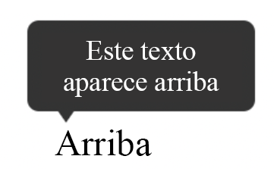

## El HTML

<div class="tooltip">

<span>Arriba</span>

<div class="tooltip-text">Este texto aparece arriba</div>

</div>

## El CSS

body {

margin: 60px;

}

.tooltip {

position: relative;

display: inline-block;

}

.tooltip-text {

padding: 6px;

background-color: #333;

color: white;

font-size: 12px;

position: absolute;

border-radius: 5px;

width: 100px;

text-align: center;

display: inline-block;

top: -45px;

left: -12px;

visibility: hidden;

}

.tooltip-text::after {

content: "";

position: absolute;

left: 10px;

bottom: -5px;

width: 0;

height: 0;

border-left: 7px solid transparent;

border-right: 7px solid transparent;

border-top: 10px solid #333;

}

.tooltip:hover .tooltip-text {

visibility: visible;

}

# 

# Plantilla n.° 2



## El HTML

<div class="tooltip">

<span>Derecha</span>

<div class="tooltip-text">Este texto aparece a la derecha</div>

</div>

## El CSS

.tooltip {

position: relative;

display: inline-block;

}

.tooltip-text {

padding: 6px;

background-color: #333;

color: white;

font-size: 12px;

position: absolute;

border-radius: 5px;

width: 100px;

text-align: center;

right: -120px;

bottom: -7px;

visibility: hidden;

}

.tooltip-text::after {

content: "";

position: absolute;

left: -5px;

bottom: 10px;

width: 0;

height: 0;

border-top: 7px solid transparent;

border-bottom: 7px solid transparent;

border-right: 10px solid #333;

}

.tooltip:hover .tooltip-text {

visibility: visible;

}

# 

# Plantilla n.° 3

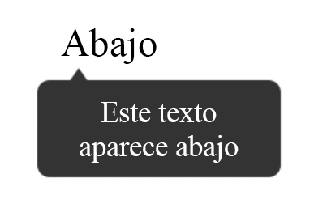

## El HTML

<div class="tooltip">

<span>Abajo</span>

<div class="tooltip-text">Este texto aparece abajo</div>

</div>

## El CSS

.tooltip {

position: relative;

display: inline-block;

}

.tooltip-text {

padding: 6px;

background-color: #333;

color: white;

font-size: 12px;

position: absolute;

border-radius: 5px;

width: 100px;

text-align: center;

display: inline-block;

bottom: -46px;

left: -10px;

visibility: hidden;

}

.tooltip-text::after {

content: "";

position: absolute;

left: 10px;

top: -5px;

width: 0;

height: 0;

border-left: 7px solid transparent;

border-right: 7px solid transparent;

border-bottom: 10px solid #333;

}

.tooltip:hover .tooltip-text {

visibility: visible;

}

# 

# Plantilla n.° 4

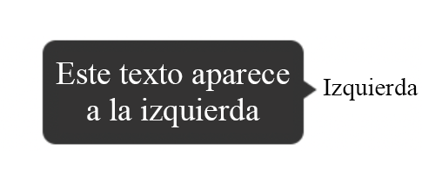

## El HTML

<div class="tooltip">

<span>Izquierda</span>

<div class="tooltip-text">Este texto aparece a la izquierda</div>

</div>

El CSS

body {

margin: 60px 130px;

}

.tooltip {

position: relative;

display: inline-block;

}

.tooltip-text {

padding: 6px;

background-color: #333;

color: white;

font-size: 12px;

position: absolute;

border-radius: 5px;

width: 100px;

text-align: center;

left: -120px;

bottom: -11px;

visibility: hidden;

}

.tooltip-text::after {

content: "";

position: absolute;

right: -5px;

top: 12px;

width: 0;

height: 0;

border-top: 7px solid transparent;

border-bottom: 7px solid transparent;

border-left: 10px solid #333;

}

.tooltip:hover .tooltip-text {

visibility: visible;

}



|  |
| --- |
| Dos plantillas para barras de progreso |
|  |

# 

# Plantilla n.° 1

## 

## El HTML

<progress class="first" value="50" max="100"></progress>

## El CSS

.first {

border-radius: 0;

border: 2px solid purple;

height: 30px;

width: 250px;

}

.first::-webkit-progress-bar {

background-color: white;

}

.first::-webkit-progress-value {

background-color: purple;

}

# 

# Plantilla n.° 2

## El HTML

<progress class="second" value="40" max="100"></progress>

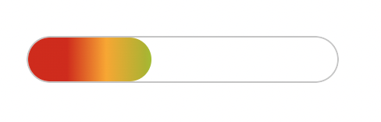

<progress class="second" value="80" max="100"></progress>

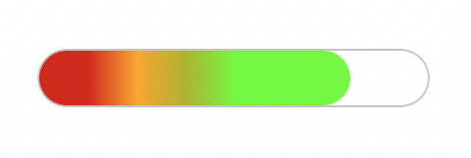

## El CSS

.second {

overflow: hidden;

border-radius: 15px;

height: 30px;

width: 200px;

}

.second::-webkit-progress-bar {

border-radius: 15px;

background-color: white;

border: 1px solid #ccc;

}

.second::-webkit-progress-value {

background-image: linear-gradient(

90deg,

hsl(0deg 91% 46%) 25px,

hsl(41deg 100% 50%) 50px,

hsl(63deg 100% 37%) 75px,

rgb(85, 255, 0) 100px

);

border-radius: 15px;

}



|  |
| --- |
| Dos plantillas para acordeones CSS |
|  |

# Plantilla n.° 1: Acordeón que usa solo CSS y HTML

## El HTML

<!DOCTYPE html>

<html lang="en">

<head>

<title>Documento</title>

<link rel="stylesheet" href="style.css" />

</head>

<body>

<div class="container">

<h1>Acordeón CCS</h1>

<div class="accordion">

<div class="tab">

<input type="checkbox" id="tab1" />

<label class="tab-label" for="tab1">Lorem ipsum 1</label>

<div class="tab-content">

Lorem ipsum dolor sit, amet consectetur adipisicing elit. Doloremque

perferendis eligendi fugit quaerat consequatur fuga pariatur

ratione, enim mollitia aut! Nobis maxime voluptas harum labore quos,

tempore itaque quas excepturi.

</div>

</div>

<div class="tab">

<input type="checkbox" id="tab2" />

<label class="tab-label" for="tab2">Lorem ipsum 2</label>

<div class="tab-content">

Lorem ipsum dolor sit, amet consectetur adipisicing elit. Doloremque

perferendis eligendi fugit quaerat consequatur fuga pariatur

ratione, enim mollitia aut! Nobis maxime voluptas harum labore quos,

tempore itaque quas excepturi.

</div>

</div>

<div class="tab">

<input type="checkbox" id="tab3" />

<label class="tab-label" for="tab3">Lorem ipsum 3</label>

<div class="tab-content">

Lorem ipsum dolor sit, amet consectetur adipisicing elit. Doloremque

perferendis eligendi fugit quaerat consequatur fuga pariatur

ratione, enim mollitia aut! Nobis maxime voluptas harum labore quos,

tempore itaque quas excepturi.

</div>

</div>

</div>

</div>

</body>

</html>

## El CSS

@import "https://fonts.googleapis.com/css?family=Montserrat:400,700|Raleway:300,400";

body {

color: #2c3e50;

background: #ecf0f1;

width: 100vw;

padding: 0 1em 1em;

font-family: "Raleway", sans-serif;

}

h1 {

margin: 0;

line-height: 2;

text-align: center;

}

input {

position: absolute;

opacity: 0;

z-index: -1;

}

/* Estilos de acordeón */

.accordion {

border-radius: 8px;

width: 70vw;

margin: 5rem auto 0;

overflow: hidden;

padding: 2rem 2.5rem;

background-color: white;

box-shadow: 0 4px 4px 2px rgba(0, 0, 0, 0.15);

}

.tab {

width: 100%;

color: #1a252f;

overflow: hidden;

margin: 1rem 0;

}

.tab-label {

display: flex;

justify-content: space-between;

padding: 1rem;

background: white;

font-weight: bold;

cursor: pointer;

}

.tab-label:hover {

background: #dce7ea;

}

.tab-label::after {

content: "❯";

width: 1em;

height: 1em;

text-align: center;

transition: all 0.35s;

}

.tab-content {

max-height: 0;

padding: 0 1em;

line-height: 2rem;

color: #1a252f;

background: white;

transition: all 0.35s;

}

.tab-close {

display: flex;

justify-content: flex-end;

padding: 1em;

font-size: 0.75em;

background: #2c3e50;

cursor: pointer;

}

.tab-close:hover {

background: #dce7ea;

}

input:checked + .tab-label {

background: #dce7ea;

}

input:checked + .tab-label::after {

transform: rotate(90deg);

}

input:checked ~ .tab-content {

max-height: 100vh;

padding: 1rem;

}

# Plantilla n.° 2: Acordeón que usa CSS, HTML y JavaScript

## El HTML

<!DOCTYPE html>

<html lang="en">

<head>

<title>Documento</title>

<link rel="stylesheet" href="style.css" />

</head>

<body>

<div class="container">

<h1>Acordeón CSS con Javascript</h1>

<div class="accordion">

<div class="tab">

<input type="checkbox" id="tab1" />

<label class="tab-label" for="tab1">Lorem ipsum 1</label>

<div class="tab-content">

Lorem ipsum dolor sit, amet consectetur adipisicing elit. Doloremque

perferendis eligendi fugit quaerat consequatur fuga pariatur

ratione, enim mollitia aut! Nobis maxime voluptas harum labore quos,

tempore itaque quas excepturi.

</div>

</div>

<div class="tab">

<input type="checkbox" id="tab2" />

<label class="tab-label" for="tab2">Lorem ipsum 2</label>

<div class="tab-content">

Lorem ipsum dolor sit, amet consectetur adipisicing elit. Doloremque

perferendis eligendi fugit quaerat consequatur fuga pariatur

ratione, enim mollitia aut! Nobis maxime voluptas harum labore quos,

tempore itaque quas excepturi.

</div>

</div>

<div class="tab">

<input type="checkbox" id="tab3" />

<label class="tab-label" for="tab3">Lorem ipsum 3</label>

<div class="tab-content">

Lorem ipsum dolor sit, amet consectetur adipisicing elit. Doloremque

perferendis eligendi fugit quaerat consequatur fuga pariatur

ratione, enim mollitia aut! Nobis maxime voluptas harum labore quos,

tempore itaque quas excepturi.

</div>

</div>

</div>

</div>

<script src="index.js"></script>

</body>

</html>

## El CSS

@import "https://fonts.googleapis.com/css?family=Montserrat:400,700|Raleway:300,400";

body {

color: #2c3e50;

background: #ecf0f1;

width: 100vw;

padding: 0 1em 1em;

font-family: "Raleway", sans-serif;

}

h1 {

margin: 0;

line-height: 2;

text-align: center;

color: #ff6873;

}

input {

position: absolute;

opacity: 0;

z-index: -1;

}

/* Estilos de acordeón */

.accordion {

border-radius: 8px;

width: 70vw;

margin: 5rem auto 0;

overflow: hidden;

padding: 2rem 2.5rem;

background-color: white;

box-shadow: 0 4px 4px 2px rgba(0, 0, 0, 0.15);

}

.tab {

width: 100%;

color: #1a252f;

overflow: hidden;

margin: 1.4rem 0;

}

.tab-label {

display: flex;

justify-content: space-between;

padding: 1rem;

font-size: 1.2rem;

color: #ff6873;

font-weight: bold;

cursor: pointer;

}

.tab-label::after {

content: "❯";

width: 1em;

height: 1em;

color: #ff6873;

text-align: center;

transition: all 0.35s;

}

.tab-content {

max-height: 0;

padding: 0 1em;

line-height: 2rem;

color: #1a252f;

background: white;

transition: all 0.35s;

}

.tab-close {

display: flex;

justify-content: flex-end;

padding: 1em;

font-size: 0.75em;

background: #2c3e50;

cursor: pointer;

}

.open-tab .tab-label::after {

transform: rotate(90deg);

}

.open-tab .tab-content {

max-height: 100vh;

padding: 1rem;

}

## El JavaScript

const accordions = document.getElementsByClassName("tab");

for (const accordion of accordions) {

accordion.addEventListener("click", function (e) {

e.preventDefault();

accordion.classList.toggle("open-tab");

});

}



|  |
| --- |
| Cuatro plantillas  para efectos CSS |
|  |

Plantilla n.° 1: Opacidad

## El HTML

<!DOCTYPE html>

<html lang="en">

<head>

<link rel="stylesheet" href="style.css" />

</head>

<body>

<div class="container">

<div class="box">

<img src="./girl-with-guitar.jpeg" alt="img" />  
 <img

src="./girl-with-guitar.jpeg"

alt="img"

class="translucent"

/>

</div>

</div>

</body>

</html>

## El CSS

*,

*::after,

*::before {

margin: 0;

padding: 0;

box-sizing: border-box;

}

.container {

display: flex;

flex-flow: column nowrap;

justify-content: space-around;

align-items: center;

min-height: 100vh;

width: 100vw;

background: #c8c7c7;

font-family: "Roboto", sans-serif;

}

.box {

width: 90%;

height: 60%;

display: flex;

flex-flow: row nowrap;

justify-content: space-around;

align-items: center;

margin: 1rem 0;

}

.box img {

width: 48%;

}

.translucent {

filter: opacity(35%);

}

# 

# Plantilla n.° 2: Escala de grises

## El HTML

<!DOCTYPE html>

<html lang="en">

<head>

<link rel="stylesheet" href="style.css" />

</head>

<body>

<div class="container">

<div class="box">

<img src="./girl-with-guitar.jpeg" alt="img" />  
 <img

src="./girl-with-guitar.jpeg"

alt="img"

class="black-white"

/>

</div>

</div>

</body>

</html>

## El CSS

*,

*::after,

*::before {

margin: 0;

padding: 0;

box-sizing: border-box;

}

.container {

display: flex;

flex-flow: column nowrap;

justify-content: space-around;

align-items: center;

min-height: 100vh;

width: 100vw;

background: #c8c7c7;

font-family: "Roboto", sans-serif;

}

.box {

width: 90%;

height: 60%;

display: flex;

flex-flow: row nowrap;

justify-content: space-around;

align-items: center;

margin: 1rem 0;

}

.box img {

width: 48%;

}

.black-white {

filter: grayscale(100%);

}

# 

# Plantilla n.° 3: Sepia

## El HTML

<!DOCTYPE html>

<html lang="en">

<head>

<link rel="stylesheet" href="style.css" />

</head>

<body>

<div class="container">

<div class="box">

<img src="./girl-with-guitar.jpeg" alt="img" />  
 <img

src="./girl-with-guitar.jpeg"

alt="img"

class="nineties-effect"

/>

</div>

</div>

</body>

</html>

## El CSS

*,

*::after,

*::before {

margin: 0;

padding: 0;

box-sizing: border-box;

}

.container {

display: flex;

flex-flow: column nowrap;

justify-content: space-around;

align-items: center;

min-height: 100vh;

width: 100vw;

background: #c8c7c7;

font-family: "Roboto", sans-serif;

}

.box {

width: 90%;

height: 60%;

display: flex;

flex-flow: row nowrap;

justify-content: space-around;

align-items: center;

margin: 1rem 0;

}

.box img {

width: 48%;

}

.nineties-effect {

filter: sepia(100%);

}

# 

# Plantilla n.° 4: Elemento sobre el que pasar el cursor

## El HTML

<!DOCTYPE html>

<html lang="en">

<head>

<link rel="stylesheet" href="style.css" />

</head>

<body>

<div class="container">

<div class="box">

<img src="./girl-with-guitar.jpeg" alt="img" />  
 <img

src="./girl-with-guitar.jpeg"

alt="img"

class="hover-effect"

/>

</div>

</div>

</body>

</html>

## El CSS

*,

*::after,

*::before {

margin: 0;

padding: 0;

box-sizing: border-box;

}

.container {

display: flex;

flex-flow: column nowrap;

justify-content: space-around;

align-items: center;

min-height: 100vh;

width: 100vw;

background: #fafafa;

/* background: #c8c7c7; */

font-family: "Roboto", sans-serif;

}

.box {

width: 90%;

height: 60%;

display: flex;

flex-flow: row nowrap;

justify-content: space-around;

align-items: center;

margin: 1rem 0;

}

.box img {

width: 48%;

}

.hover-effect:hover {

filter: grayscale(100%);

}



|  |
| --- |
| Dos plantillas para pestañas de navegación CSS |

Plantilla n.° 1: CSS Pestaña de navegación CSS con efectos de animación

## El HTML

<!DOCTYPE html>

<html lang="en">

<head>

<title>Documento</title>

<link rel="stylesheet" href="styles.css" />

</head>

<body>

<!-- Galería de imágenes con pestañas -->

<div class="tabbed-gallery">

<div class="btn-row">

<button class="btn active-btn">Nueva York</button>

<button class="btn">Honolulú</button>

<button class="btn">Seúl</button>

</div>

<div id="New York" class="city">

<img src="./img/new-york.jpeg" alt="New York" class="" />

<p>Nueva York</p>

</div>

<div id="Honolulu" class="city hidden-city">

<img src="./img/honolulu.jpeg" alt="Honolulu" class="" />

<p>Honolulú</p>

</div>

<div id="Seoul" class="city hidden-city">

<img src="./img/seoul.jpeg" alt="Seoul" class="" />

<p>Seúl</p>

</div>

</div>

<script src="index.js"></script>

</body>

</html>

## El CSS

@import url("https://fonts.googleapis.com/css2?family=DynaPuff&display=swap");

* {

padding: 0;

margin: 0;

box-sizing: border-box;

font-family: "DynaPuff", cursive, sans-serif;

}

body {

width: 100vw;

}

.tabbed-gallery {

width: 80vw;

margin: 6rem auto 0;

}

.btn-row {

display: grid;

grid-template-columns: repeat(3, 8rem);

grid-template-rows: 3.5rem;

column-gap: 8rem;

justify-content: center;

padding: 2rem auto;

background-color: #1d1d27;

}

.btn {

padding: 4px 2px;

font-size: 1.2rem;

border: none;

outline: none;

transition: all 300ms ease;

}

.btn:hover {

cursor: pointer;

}

.active-btn {

color: #fafafa;

background-color: #4343f5;

}

.city {

width: 100%;

height: 75vh;

position: relative;

display: block;

transition: all 400ms ease;

}

.hidden-city {

display: none;

}

.city img {

width: 100%;

height: 100%;

image-rendering: optimizeQuality;

}

.city p {

position: absolute;

bottom: 15%;

left: 50%;

transform: translate(-50%);

text-align: center;

color: #fafafa;

font-size: 3.5rem;

}

## El JavaScript

const buttons = document.querySelectorAll(".btn");

const cities = document.querySelectorAll(".city");

function showCity(e, index) {

//añade la clase hidden-city a todos los elemento de imagen y elimina la clase active-btn de todos los botones

for (let i = 0; i < cities.length; i++) {

cities[i].classList.add("hidden-city");

buttons[i].classList.remove("active-btn");

}

//añade la clase active-btn al botón en el que se ha hecho clic

e.target.classList.add("active-btn");

// selecciona la ciudad adecuada y la hace visible

cities[index].classList.remove("hidden-city");

}

buttons.forEach((button, index) => {

button.addEventListener("click", (e) => {

showCity(e, index);

});

});

# Plantilla n.° 2: Pestaña de navegación CSS con una galería de imagen sencilla con pestañas

## El HTML

<!DOCTYPE html>

<html lang="en">

<head>

<title>Documento</title>

<link rel="stylesheet" href="styles.css" />

</head>

<body>

<!-- Galería de imágenes con pestañas -->

<div class="tabbed-gallery">

<div class="btn-row">

<button class="btn active-btn">

<svg viewBox="0 0 24 24">

<path

d="M2,10.96C1.5,10.68 1.35,10.07 1.63,9.59L3.13,7C3.24,6.8 3.41,6.66 3.6,6.58L11.43,2.18C11.59,2.06 11.79,2 12,2C12.21,2 12.41,2.06 12.57,2.18L20.47,6.62C20.66,6.72 20.82,6.88 20.91,7.08L22.36,9.6C22.64,10.08 22.47,10.69 22,10.96L21,11.54V16.5C21,16.88 20.79,17.21 20.47,17.38L12.57,21.82C12.41,21.94 12.21,22 12,22C11.79,22 11.59,21.94 11.43,21.82L3.53,17.38C3.21,17.21 3,16.88 3,16.5V10.96C2.7,11.13 2.32,11.14 2,10.96M12,4.15V4.15L12,10.85V10.85L17.96,7.5L12,4.15M5,15.91L11,19.29V12.58L5,9.21V15.91M19,15.91V12.69L14,15.59C13.67,15.77 13.3,15.76 13,15.6V19.29L19,15.91M13.85,13.36L20.13,9.73L19.55,8.72L13.27,12.35L13.85,13.36Z"

/>

</svg>

</button>

<button class="btn">

<svg viewBox="0 0 24 24">

<path

d="M3,4A2,2 0 0,0 1,6V17H3A3,3 0 0,0 6,20A3,3 0 0,0 9,17H15A3,3 0 0,0 18,20A3,3 0 0,0 21,17H23V12L20,8H17V4M10,6L14,10L10,14V11H4V9H10M17,9.5H19.5L21.47,12H17M6,15.5A1.5,1.5 0 0,1 7.5,17A1.5,1.5 0 0,1 6,18.5A1.5,1.5 0 0,1 4.5,17A1.5,1.5 0 0,1 6,15.5M18,15.5A1.5,1.5 0 0,1 19.5,17A1.5,1.5 0 0,1 18,18.5A1.5,1.5 0 0,1 16.5,17A1.5,1.5 0 0,1 18,15.5Z"

/>

</svg>

</button>

<button class="btn">

<svg viewBox="0 0 24 24">

<path

d="M11,9H13V7H11M12,20C7.59,20 4,16.41 4,12C4,7.59 7.59,4 12,4C16.41,4 20,7.59 20,12C20,16.41 16.41,20 12,20M12,2A10,10 0 0,0 2,12A10,10 0 0,0 12,22A10,10 0 0,0 22,12A10,10 0 0,0 12,2M11,17H13V11H11V17Z"

/>

</svg>

</button>

</div>

<div class="card">

<h2 class="">Entrega</h2>

<p>Lorem ipsum dolor, sit amet consectetur adipisicing elit.</p>

</div>

<div class="card hidden-card">

<h2 class="">Envío</h2>

<p>Lorem ipsum dolor, sit amet consectetur adipisicing elit.</p>

</div>

<div class="card hidden-card">

<h2 class="">Política</h2>

<p>Lorem ipsum dolor, sit amet consectetur adipisicing elit.</p>

</div>

</div>

<script src="index.js"></script>

</body>

</html>

## 

## 

## El CSS

@import "https://fonts.googleapis.com/css?family=Montserrat:400,700|Raleway:300,400";

* {

padding: 0;

margin: 0;

box-sizing: border-box;

font-family: "Raleway", sans-serif;

}

body {

width: 100vw;

background: #fff;

}

.tabbed-gallery {

width: 80vw;

height: 75vh;

background-color: #e7e7e7;

color: #1d1d27;

margin: 6rem auto 0;

}

.btn-row {

display: grid;

grid-template-columns: repeat(3, 8rem);

grid-template-rows: 3.5rem;

column-gap: 10rem;

justify-content: center;

padding: 4rem auto !important;

border-bottom: 2px solid #1d1d27;

}

.btn {

border: none;

outline: none;

background-color: #fff;

}

.btn svg {

width: 3rem;

height: 2.2rem;

}

.btn:hover {

cursor: pointer;

}

.active-btn svg {

fill: #4343f5;

}

.card {

width: 100%;

height: 70vh;

position: relative;

display: block;

}

h2 {

text-align: center;

color: #4343f5;

padding: 40px 0 20px 0;

margin-top: 10rem;

font-size: 4rem;

}

.card p {

/* position: absolute;

top: 30%;

left: 50%;

transform: translate(-50%); */

margin: 0 auto;

width: 60%;

text-align: center;

color: #1d1d27;

font-size: 1.5rem;

}

.animate h2,

.animate p {

-webkit-animation-name: content;

animation-name: content;

-webkit-animation-direction: normal;

animation-direction: normal;

-webkit-animation-duration: 0.5s;

animation-duration: 0.5s;

-webkit-animation-timing-function: ease-in-out;

animation-timing-function: ease-in-out;

-webkit-animation-iteration-count: 1;

animation-iteration-count: 1;

line-height: 1.4;

}

.hidden-card {

display: none;

}

/* animación de texto que se desplaza hacia arriba */

@-webkit-keyframes content {

from {

opacity: 0;

transform: translateY(30%);

}

to {

opacity: 1;

transform: translateY(0%);

}

}

@keyframes content {

from {

opacity: 0;

transform: translateY(30%);

}

to {

opacity: 1;

transform: translateY(0%);

}

}

## El JavaScript

const buttons = document.querySelectorAll(".btn");

const cards = document.querySelectorAll(".card");

function showCard(e, index) {

//añade la clase hidden-city a todos los elementos de ciudad y elimina la clase active-btn de todos los botones

for (let i = 0; i < cards.length; i++) {

cards[i].classList.add("hidden-card");

cards[i].classList.remove("animate");

buttons[i].classList.remove("active-btn");

}

//añade la clase active-btn al botón en el que se ha hecho clic

e.target.classList.add("active-btn");

// selecciona la tarjeta adecuada y la hace visible

cards[index].classList.remove("hidden-card");

cards[index].classList.add("animate");

}

buttons.forEach((button, index) => {

button.addEventListener("click", (e) => {

showCard(e, index);

});

});



|  |
| --- |
| Dos plantillas para presentaciones  de CSS y JavaScript  \]\\\]\\\\ |
|  |

Plantilla n.° 1: Presentación que avanza manualmente

## El HTML

<!DOCTYPE html>

<html lang="en">

<head>

<link rel="stylesheet" href="style.css" />

</head>

<body>

<div class="carousel">

<!-- Foto 1 -->

<div class="card">

<img src="./img/1.jpeg" alt="New York" class="" />

<p>1/4</p>

</div>

<!-- Foto 2 -->

<div class="card hidden-card">

<img src="./img/2.jpeg" alt="New York" class="" />

<p>2/4</p>

</div>

<!-- Foto 3 -->

<div class="card hidden-card">

<img src="./img/3.jpeg" alt="New York" class="" />

<p>3/4</p>

</div>

<!-- Foto 4 -->

<div class="card hidden-card">

<img src="./img/4.jpeg" alt="New York" class="" />

<p>4/4</p>

</div>

<div class="navigation">

<button class="prev nav-btn"><</button>

<button class="next nav-btn">></button>

</div>

</div>

</body>

<script src="index.js"></script>

</html>

## El CSS

@import url("https://fonts.googleapis.com/css2?family=DynaPuff&display=swap");

* {

padding: 0;

margin: 0;

box-sizing: border-box;

font-family: "DynaPuff", cursive, sans-serif;

}

html,

body {

display: flex;

align-items: center;

justify-content: center;

align-items: center;

width: 100vw;

height: 100vh;

background-color: #3c3c3c;

}

.carousel {

width: 80%;

height: 75vh;

position: relative;

display: block;

transition: all 400ms ease;

}

.card {

display: block;

height: 100%;

width: 100%;

}

.card p {

position: absolute;

bottom: 12%;

left: 50%;

transform: translate(-50%);

text-align: center;

color: #fafafa;

font-size: 3.5rem;

}

.card img {

width: 100%;

height: 100%;

image-rendering: optimizeQuality;

transition: all 0.3s ease;

border: 8px solid white;

}

.hidden-card {

display: none;

}

.carousel img {

width: 100%;

transition: all 0.3s ease;

border: 8px solid white;

}

.navigation .prev {

position: absolute;

z-index: 10;

font-size: 25px;

top: 40%;

left: 20px;

font-weight: 700;

}

.navigation .next {

right: 20px;

position: absolute;

font-size: 25px;

z-index: 10;

top: 40%;

}

.navigation .nav-btn {

background: rgba(255, 255, 255, 0.55);

border: none;

outline: none;

cursor: pointer;

border-radius: 50%;

width: 40px;

height: 40px;

display: flex;

justify-content: center;

align-items: center;

padding: 10px;

box-shadow: 2px 2px 10px rgba(0, 0, 0, 0.4);

}

.navigation .nav-btn:hover {

background: white;

}

## El JavaScript

const prev = document.querySelector(".prev");

const next = document.querySelector(".next");

const images = document.querySelectorAll(".card");

const totalImages = images.length;

let index = 0;

prev.addEventListener("click", () => {

nextImage("prev");

});

next.addEventListener("click", () => {

nextImage("next");

});

function nextImage(direction) {

if (direction === "next") {

index++;

if (index === totalImages) {

index = 0;

}

} else if (direction === "prev") {

if (index == 0) {

index = totalImages - 1;

} else {

index--;

}

}

for (let i = 0; i < images.length; i++) {

images[i].classList.add("hidden-card");

}

images[index].classList.remove("hidden-card");

}

# Plantilla n.° 2: Presentación que avanza automáticamente

## El HTML

<!DOCTYPE html>

<html lang="en">

<head>

<title>Documento</title>

<link rel="stylesheet" href="style.css" />

</head>

<body>

<div class="carousel">

<!-- Foto 1 -->

<div class="card">

<img src="./img/1.jpeg" alt="New York" class="" />

<p>1/4</p>

</div>

<!-- Foto 2 -->

<div class="card hidden-card">

<img src="./img/2.jpeg" alt="New York" class="" />

<p>2/4</p>

</div>

<!-- Foto 3 -->

<div class="card hidden-card">

<img src="./img/3.jpeg" alt="New York" class="" />

<p>3/4</p>

</div>

<!-- Foto 4 -->

<div class="card hidden-card">

<img src="./img/4.jpeg" alt="New York" class="" />

<p>4/4</p>

</div>

<div class="navigation">

<button class="prev nav-btn"><</button>

<button class="next nav-btn">></button>

</div>

</div>

</body>

<script src="index.js"></script>

</html>

## El CSS

@import url("https://fonts.googleapis.com/css2?family=DynaPuff&display=swap");

* {

padding: 0;

margin: 0;

box-sizing: border-box;

font-family: "DynaPuff", cursive, sans-serif;

}

html,

body {

display: flex;

align-items: center;

justify-content: center;

align-items: center;

width: 100vw;

height: 100vh;

background-color: #3c3c3c;

}

.carousel {

width: 80%;

height: 75vh;

position: relative;

display: block;

transition: all 400ms ease;

}

.card {

display: block;

height: 100%;

width: 100%;

}

.card p {

position: absolute;

bottom: 12%;

left: 50%;

transform: translate(-50%);

text-align: center;

color: #fafafa;

font-size: 3.5rem;

}

.card img {

width: 100%;

height: 100%;

image-rendering: optimizeQuality;

transition: all 0.3s ease;

border: 8px solid white;

}

.hidden-card {

display: none;

}

.carousel img {

width: 100%;

transition: all 0.3s ease;

border: 8px solid white;

}

.navigation .prev {

position: absolute;

z-index: 10;

font-size: 25px;

top: 40%;

left: 20px;

font-weight: 700;

}

.navigation .next {

right: 20px;

position: absolute;

font-size: 25px;

z-index: 10;

top: 40%;

}

.navigation .nav-btn {

background: rgba(255, 255, 255, 0.55);

border: none;

outline: none;

cursor: pointer;

border-radius: 50%;

width: 40px;

height: 40px;

display: flex;

justify-content: center;

align-items: center;

padding: 10px;

box-shadow: 2px 2px 10px rgba(0, 0, 0, 0.4);

}

.navigation .nav-btn:hover {

background: white;

}

## El JavaScript

const prev = document.querySelector(".prev");

const next = document.querySelector(".next");

const images = document.querySelectorAll(".card");

const totalImages = images.length;

let index = 0;

prev.addEventListener("click", () => {

nextImage("prev");

});

next.addEventListener("click", () => {

nextImage("next");

});

function nextImage(direction) {

if (direction === "next") {

index++;

if (index === totalImages) {

index = 0;

}

} else if (direction === "prev") {

if (index == 0) {

index = totalImages - 1;

} else {

index--;

}

}

for (let i = 0; i < images.length; i++) {

images[i].classList.add("hidden-card");

}

images[index].classList.remove("hidden-card");

}

setInterval(() => {

nextImage("next");

}, 5000);



|  |
| --- |
| Tres plantillas de JavaScript onClick  con CSS |

# Plantilla n.° 1: Mostrar un elemento oculto

## El HTML

<!DOCTYPE html>

<html lang="en">

<head>

<title>Documento</title>

<link rel="stylesheet" href="styles.css" />

</head>

<body>

<div class="container hidden-container">

<img src="./honolulu.jpeg" alt="Honolulu" class="img" />

<button class="fixed-btn">Mostrar u ocultar imagen</button>

</div>

<script src="index.js"></script>

</body>

</html>

## El CSS

@import url("https://fonts.googleapis.com/css2?family=DynaPuff&display=swap::400,700|Raleway:300,400");

* {

padding: 0;

margin: 0;

box-sizing: border-box;

font-family: "DynaPuff", cursive, sans-serif;

}

body {

width: 100vw;

min-height: 100vh;

background: #fafafa;

}

.container {

height: 100vh;

width: 100%;

display: flex;

justify-content: center;

align-items: center;

position: relative;

}

.fixed-btn {

border: none;

outline: none;

background-color: #1d1d27;

color: #fafafa;

padding: 1.5rem 1rem;

font-size: 1.2rem;

position: absolute;

bottom: 10%;

left: 50%;

transform: translate(-50%);

cursor: pointer;

}

.hidden-container {

display: flex;

justify-content: center;

align-items: center;

}

.hidden-container img {

transform: translateY(-2rem);

width: 50%;

height: 70vh;

}

.hidden {

visibility: hidden;

transition: all 400ms ease;

}

## El JavaScript

const toggleBtn = document.querySelector(".fixed-btn");

const hiddenImage = document.querySelector(".hidden-container img");

toggleBtn.addEventListener("click", (e) => {

hiddenImage.classList.toggle("hidden");

});

# 

# Plantilla n.° 2: Actualización de un campo

## El HTML

<!DOCTYPE html>

<html lang="en">

<head>

<title>Documento</title>

<link rel="stylesheet" href="styles.css" />

</head>

<body>

<div class="container">

<textarea id="text-area" cols="50" rows="20"> </textarea>

<button class="fill-btn">Rellenar con texto</button>

</div>

<script src="index.js"></script>

</body>

</html>

## El CSS

@import url("https://fonts.googleapis.com/css2?family=DynaPuff&display=swap::400,700|Raleway:300,400");

* {

padding: 0;

margin: 0;

box-sizing: border-box;

font-family: "DynaPuff", cursive, sans-serif;

}

body {

width: 100vw;

min-height: 100vh;

background: #fafafa;

}

.container {

height: 100vh;

width: 100%;

display: flex;

justify-content: center;

align-items: center;

position: relative;

}

.fixed-btn {

border: none;

outline: none;

background-color: #1d1d27;

color: #fafafa;

padding: 1.5rem 1rem;

font-size: 1.2rem;

position: absolute;

bottom: 10%;

left: 50%;

transform: translate(-50%);

cursor: pointer;

}

textarea {

color: #1d1d27;

font-size: 1.5rem;

line-height: 2rem;

letter-spacing: 0.1rem;

}

## El JavaScript

const fillBtn = document.querySelector(".fill-btn");

const textarea = document.getElementById("text-area");

fillBtn.addEventListener("click", () => {

textarea.innerHTML =

"Lorem ipsum dolor sit amet consectetur adipisicing elit. Magnam hic a vel perspiciatis asperiores, repudiandae rem nemo velit doloribus odit fugit, sed recusandae, minus voluptatem possimus autem molestias non aperiam\n\nLorem ipsum dolor sit amet consectetur adipisicing elit. Magnam hic a vel perspiciatis asperiores";

});

# Plantilla n.° 3: Cambio de color u otros efectos visuales

## El HTML

<!DOCTYPE html>

<html lang="en">

<head>

<title>Documento</title>

<link rel="stylesheet" href="styles.css" />

</head>

<body>

<div class="container bg-container">

<button class="fixed-btn">Nuevo color</button>

</div>

<script src="index.js"></script>

</body>

</html>

## El CSS

@import url("https://fonts.googleapis.com/css2?family=DynaPuff&display=swap::400,700|Raleway:300,400");

* {

padding: 0;

margin: 0;

box-sizing: border-box;

font-family: "DynaPuff", cursive, sans-serif;

}

body {

width: 100vw;

min-height: 100vh;

background: #fafafa;

}

.container {

height: 100vh;

width: 100%;

display: flex;

justify-content: center;

align-items: center;

position: relative;

}

.fixed-btn {

border: none;

outline: none;

background-color: #1d1d27;

color: #fafafa;

padding: 1.5rem 1rem;

font-size: 1.2rem;

position: absolute;

bottom: 10%;

left: 50%;

transform: translate(-50%);

}

.bg-container {

background-color: #4343f5;

}

## El JavaScript

const toggleBtn = document.querySelector(".bg-container .fixed-btn");

const container = document.querySelector(".bg-container");

const colors = [

"#cdb4db",

"#ffc8dd",

"#ffafcc",

"#bde0fe",

"#a2d2ff",

"#00b4d8",

"#6f2dbd",

"#f27059",

];

toggleBtn.addEventListener("click", (e) => {

e.preventDefault();

container.style.backgroundColor =

colors[Math.floor(Math.random() * colors.length)];

});



|  |
| --- |
| Una plantilla para video y audio HTML |
|  |

<!-- Elemento básico de video -->

<video src="./media/example-video.mp4"></video>

<!-- Funciones de control estándar para el usuario -->

<video controls src="./media/example-video.mp4"></video>

<!-- Anchura y altura en píxeles -->

<video width="500" height="500" src="./media/example-video.mp4"></video>

<!-- Reproducción automática de video -->

<video autoplay src="./media/example-video.mp4"></video>

<style>

/* Elemento de video estilizado */

video { /* Añade a los elementos de video un borde rojo */

border-width: 5px;

border-color: red;

}

</style>

<!-- Elemento de audio con controles -->

<audio controls src="./media/example-audio.mp3"></audio>

<style>

/* Elemento de audio estilizado. Nota: Solo puede usarse si los controles están visibles */

audio {

border-width: 5px;

border-radius: green;

}

</style>



|  |
| --- |
| Una plantilla para fondos CSS |
|  |

Plantilla

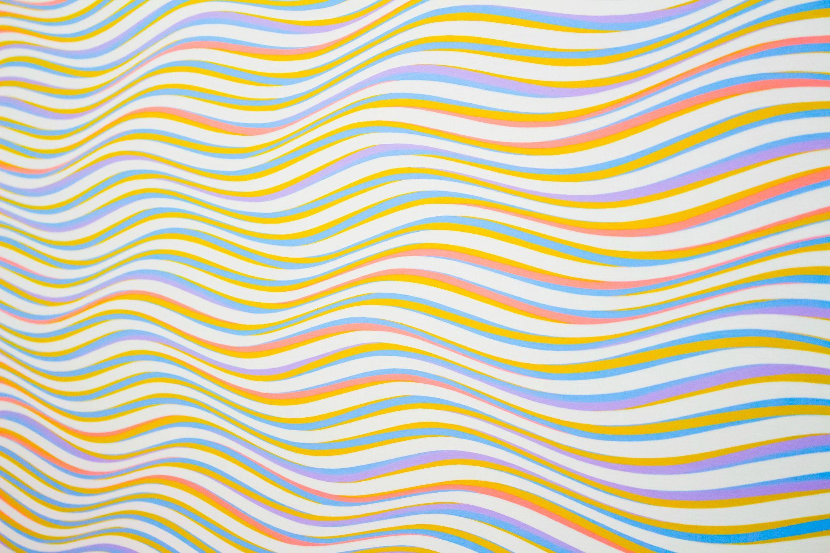

[Ejemplo](https://www.pexels.com/photo/assorted-color-striped-illustration-310452/)

/* Definir el fondo entero de la página como un color */

body {

background: red;

}

/* A la URL de una imagen */

body {

background: url("./images/image.png");

}

/*Varios fondos*/

body {

background-image: url(rose.png), url(Android-Logo.png);

background-position: right bottom, left top;

background-repeat: no-repeat, repeat;

}

/* Fondo transparente */

body {

background: green;

opacity: 0.5; /* 50% opacity */

}

/* Imagen colocada en el centro */

body {

background: center url("./images/image.png");

}

/* Repetir una imagen */

body {

background: repeat-x url("./images/image.png");

}

/* No repetir una imagen */

body {

background: no-repeat url("./images/image.png");

}

/* Definir el fondo de un elemento específico con el identificador 'my-element' */

#my-element {

background: red;

}

/* Modo de fusión con el fondo */

body{

background:

radial-gradient(

red 40px,

transparent 0,

transparent 100%

),

radial-gradient(

green 40px,

transparent 0,

transparent 100%

),

radial-gradient(

blue 40px,

transparent 0,

transparent 100%

), snow;

background-blend-mode: multiply;

background-size: 100px 100px;

background-position: 0 0, 33px 33px, -33px -33px;

}

/* Este ejemplo demuestra cómo puede añadirse un filtro de imagen de fondo */

body{

background-image:

conic-gradient(red, white, green, yellow, brown),

url(rose.png);

background-blend-mode: color-burn;

}



|  |
| --- |
| Una plantilla para degradados CSS |
|  |

<div class="container">

<div class="square left-gradient"></div>

<div class="square right-gradient"></div>

<div class="square diagonal-gradient"></div>

<div class="square angled-gradient"></div>

<div class="square rainbow-gradient"></div>

<div class="square transparent-gradient"></div>

<div class="square repeating-gradient"></div>

<div class="square conic-gradient"></div>

<div class="square radial-gradient"></div>

<div class="square multiple-gradient"></div>

</div>

<style>

.left-gradient {

background: linear-gradient(to left, red, green);

}

/* Degradado de derecha a izquierda */

.right-gradient {

background: linear-gradient(to right, red, green);

}

/* Degradado diagonal */

.diagonal-gradient {

background: linear-gradient(to top left, red, green);

}

/* Degradado en ángulo de 33 grados */

.angled-gradient {

background: linear-gradient(33deg, red, green);

}

/* Degradado de varios colores */

.rainbow-gradient {

background: linear-gradient(to left, red, orange, yellow, green, blue, indigo, violet);

}

/* Degradado parcialmente transparente */

.transparent-gradient {

background: linear-gradient(to left, red, green);

opacity: 0.5;

}

.radial-gradient {

background: radial-gradient(white, yellow, brown);

}

.conic-gradient {

background: conic-gradient(red, white, green, yellow, brown);

height: 400px;

width: 400px;

}

.repeating-gradient {

height: 400px;

background-image: repeating-linear-gradient(white, yellow, brown);

}

.multiple-gradient {

background-image:

linear-gradient(to left, red, green), radial-gradient(white, yellow, brown);

}

</style>



|  |
| --- |
| Una plantilla para desplegables CSS |
|  |

<div class="container">

<div class="square hidden-overflow">

Lorem ipsum dolor sit amet, consectetur adipisicing elit, sed do eiusmod

tempor incididunt ut labore et dolore magna aliqua. Ut enim ad minim veniam,

quis nostrud exercitation ullamco laboris nisi ut aliquip ex ea commodo

consequat. Duis aute irure dolor in reprehenderit in voluptate velit esse

cillum dolore eu fugiat nulla pariatur. Excepteur sint occaecat cupidatat non

proident, sunt in culpa qui officia deserunt mollit anim id est laborum.

</div>

<div class="square scroll-overflow">

Lorem ipsum dolor sit amet, consectetur adipisicing elit, sed do eiusmod

tempor incididunt ut labore et dolore magna aliqua. Ut enim ad minim veniam,

quis nostrud exercitation ullamco laboris nisi ut aliquip ex ea commodo

consequat. Duis aute irure dolor in reprehenderit in voluptate velit esse

cillum dolore eu fugiat nulla pariatur. Excepteur sint occaecat cupidatat non

proident, sunt in culpa qui officia deserunt mollit anim id est laborum.

</div>

<div class="square auto-overflow">

Lorem ipsum dolor sit amet, consectetur adipisicing elit, sed do eiusmod

tempor incididunt ut labore et dolore magna aliqua. Ut enim ad minim veniam,

quis nostrud exercitation ullamco laboris nisi ut aliquip ex ea commodo

consequat. Duis aute irure dolor in reprehenderit in voluptate velit esse

cillum dolore eu fugiat nulla pariatur. Excepteur sint occaecat cupidatat non

proident, sunt in culpa qui officia deserunt mollit anim id est laborum.

</div>

<div class="square visible-overflow">

Lorem ipsum dolor sit amet, consectetur adipisicing elit, sed do eiusmod

tempor incididunt ut labore et dolore magna aliqua. Ut enim ad minim veniam,

quis nostrud exercitation ullamco laboris nisi ut aliquip ex ea commodo

consequat. Duis aute irure dolor in reprehenderit in voluptate velit esse

cillum dolore eu fugiat nulla pariatur. Excepteur sint occaecat cupidatat non

proident, sunt in culpa qui officia deserunt mollit anim id est laborum.

</div>

<div class="square visible-overflow-x">

<ol>

<li>Juan</li>

<li>Daniel</li>

<li>Miguel</li>

<li>Gloria</li>

<li>Fátima</li>

<li>Juana</li>

<li>María</li>

<li>Lorenzo</li>

<li>Núria</li>

<li>Caleb</li>

<li>Eusebio</li>

</ol>

</div>

<div class="square hidden-overflow-y">

<ol>

<li>Juan</li>

<li>Daniel</li>

<li>Miguel</li>

<li>Gloria</li>

<li>Estrella</li>

<li>Juana</li>

<li>María</li>

<li>Lorenzo</li>

<li>Núria</li>

<li>Caleb</li>

<li>Eusebio</li>

</ol>

</div>

</div>

<div class="container" style="margin-top: 10%">

<div class="rectangle overflow-wrap-normal">

La palabra más larga en español es 'electroencefalografista'

</div>

<div class="rectangle overflow-wrap-break">

La palabra más larga en español es 'electroencefalografista'

</div>

<div class="rectangle-max-height visible-overflow-x">

Lorem ipsum dolor sit amet, consectetur adipisicing elit, sed do eiusmod

tempor incididunt ut labore et dolore magna aliqua. Ut enim ad minim veniam,

quis nostrud exercitation ullamco laboris nisi ut aliquip ex ea commodo

consequat. Duis aute irure dolor in reprehenderit in voluptate velit esse

cillum dolore eu fugiat nulla pariatur. Excepteur sint occaecat cupidatat non

proident, sunt in culpa qui officia deserunt mollit anim id est laborum.

</div>

</div>

<div class="rectangle-max-width visible-overflow">

La palabra más larga en español es 'electroencefalografista'

</div>

<style type="text/css">

/* desplegable visible */

.container {

display: flex;

}

.square {

width: 150px;

height: 150px;

background-color: lightblue;

margin: 1em;

display: flex;

flex-direction: column;

justify-content: center;

align-items: center;

}

.rectangle {

width: 300px;

height: 50px;

background-color: lightblue;

margin: 1em;

justify-content: center;

align-items: center;

}

.rectangle-max-height{

width: 250px;

max-height: 50px;

background-color: lightblue;

margin: 1em;

justify-content: center;

align-items: center;

}

.rectangle-max-width{

max-width: 350px;

max-height: 20px;

background-color: lightblue;

margin: 1em;

}

.visible-overflow {

overflow: visible;

}

.hidden-overflow {

overflow: hidden;

}

.scroll-overflow {

overflow: scroll;

}

.auto-overflow {

overflow: auto;

}

.visible-overflow-x {

overflow-x: visible;

}

.visible-overflow-y {

overflow-y: visible;

}

.hidden-overflow-y {

overflow-y: hidden;

}

.overflow-wrap-normal {

overflow-wrap: normal;

}

.overflow-wrap-break {

overflow-wrap: break-word;

}

</style>



|  |
| --- |
| Plantilla para animaciones CSS |
|  |

<html>

<body>

<div class="container">

<!-- Plantilla n.° 1: Cambio de color -->

<div class="green-square green-red-alternate"></div>

<!-- Plantilla n.° 2: Desplazamiento por la pantalla -->

<div class="black-circle vertical-alternate-fast"></div>

<!-- Plantilla n.° 3: Cambio de color al pasar el cursor por encima-->

<div class="green-rounded-square color-transition"></div>

</div>

</body>

</html>

<style>

.container {

display: flex;

flex-direction: row;

overflow: hidden;

}

/* Plantilla n.° 1: Cambio de color */

.green-square {

width: 200px;

height: 200px;

background-color: green;

}

.green-red-alternate {

animation-name: to-red;

animation-duration: 3s;

animation-iteration-count: infinite;

animation-direction: alternate;

}

@keyframes to-red {

from {

background-color: green;

}

to {

background-color: red;

}

}

/* Plantilla n.° 2: Desplazamiento por la pantalla */

.black-circle {

width: 200px;

height: 200px;

border-radius: 100%;

background-color: black;

}

/* Plantilla n.° 2.A: Desplazamiento lento horizontal */

.horizontal-alternate {

animation-name: left-to-right;

animation-duration: 3s;

animation-iteration-count: infinite;

animation-direction: alternate;

}

@keyframes left-to-right {

from {

margin-left: 0%;

}

to {

margin-left: 100%;

}

}

/* Plantilla n.° 2.B: Movimiento rápido horizontal */

.vertical-alternate-fast {

animation-name: top-to-bottom;

animation-duration: 1s;

animation-iteration-count: infinite;

animation-direction: alternate;

}

@keyframes top-to-bottom {

from {

margin-top: 0%;

}

to {

margin-top: 100%;

}

}

/* Plantilla n.° 3: Animación al pasar el cursor */

.green-rounded-square {

width: 200px;

height: 200px;

background-color: green;

border-radius: 1em;

}

.color-transition:hover {

animation-name: to-red;

animation-duration: 3s;

animation-iteration-count: infinite;

animation-direction: alternate;

}

</style>